**Configure Tomcat Web Server in Eclipse**

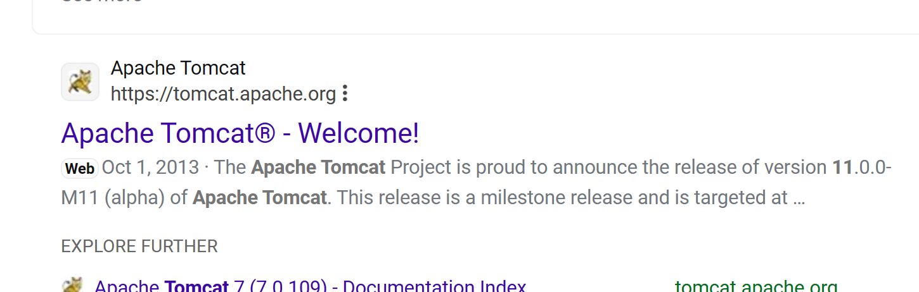

Open and click on Tomcat 10 in left hand side window:

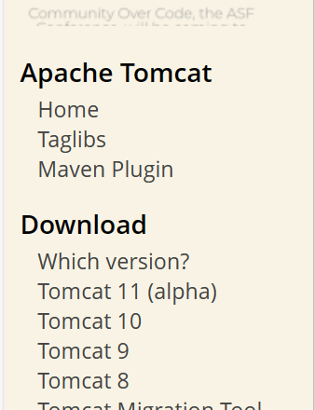

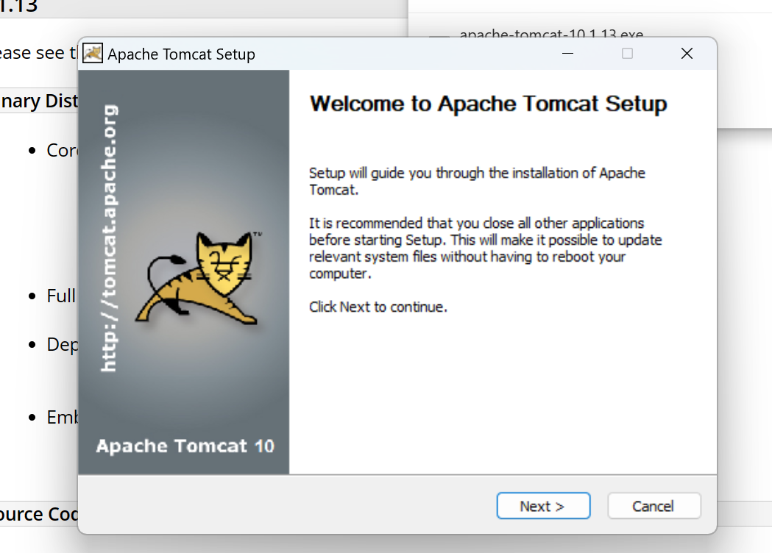

Click on next:

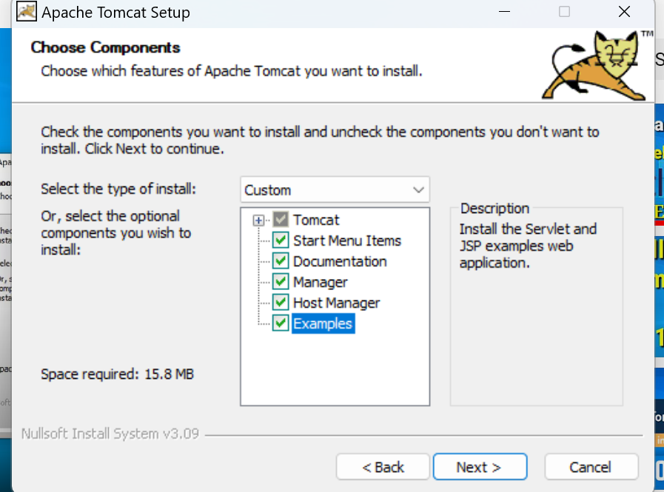

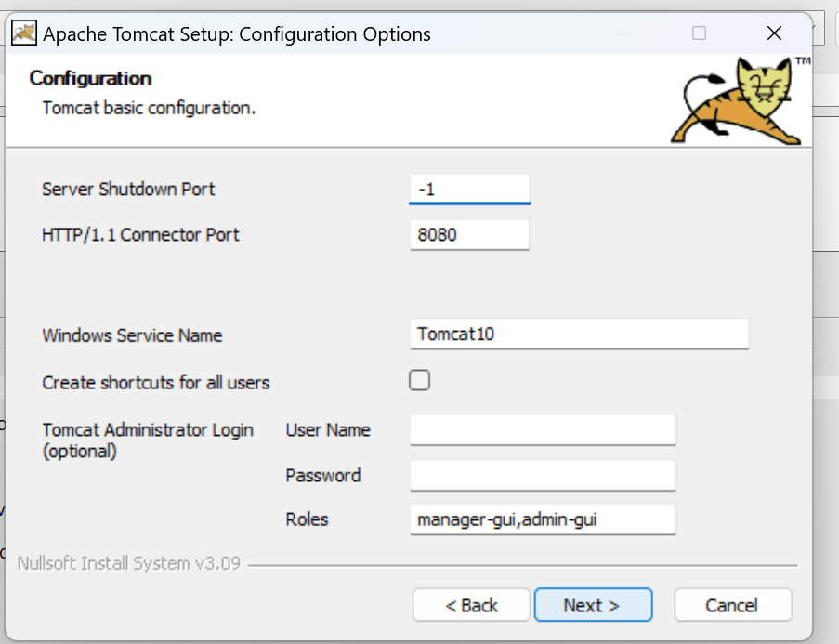

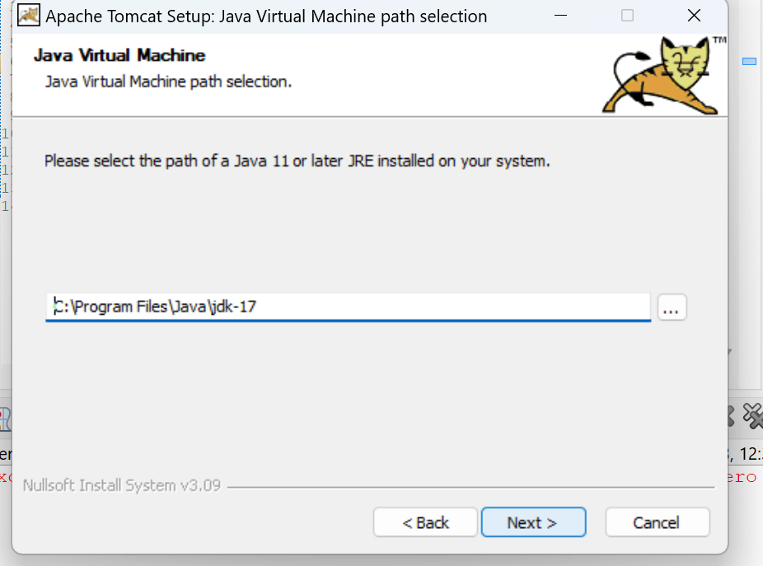

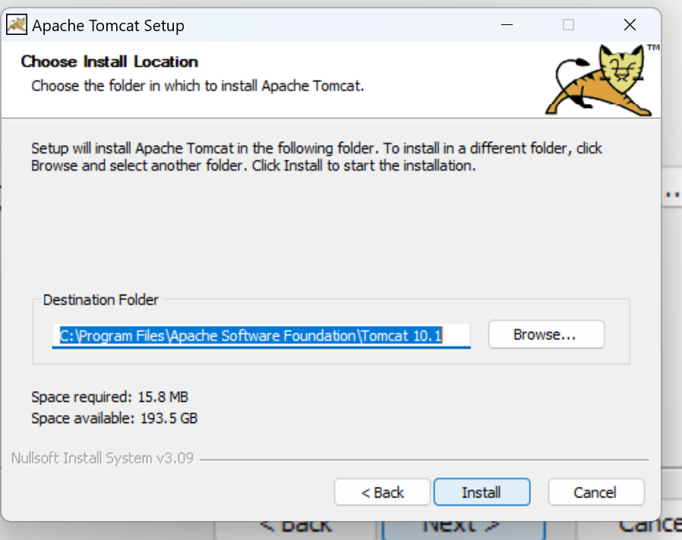

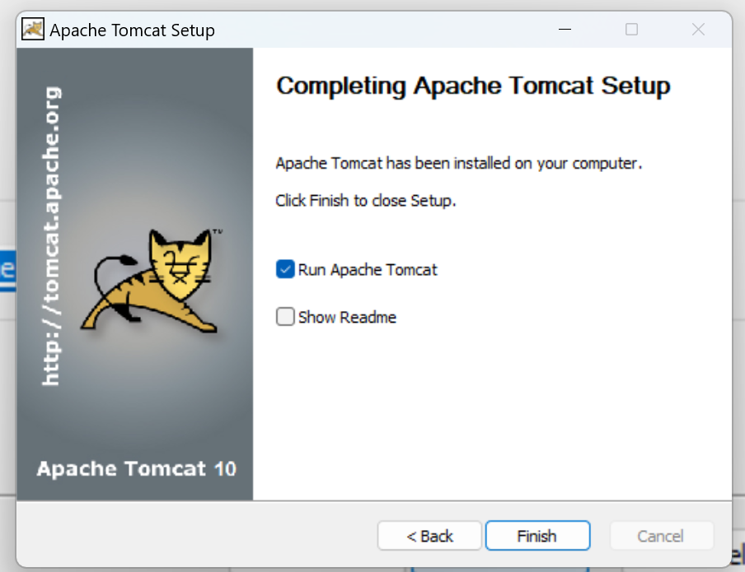

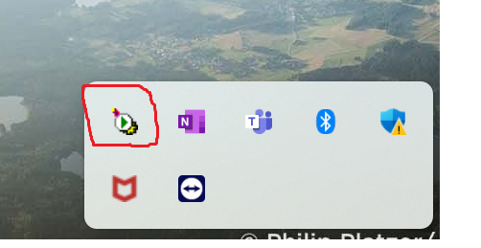 Tomcat server.

My Tomcat server is installed.

Now Configure the Tomcat server In Eclipse IDE:

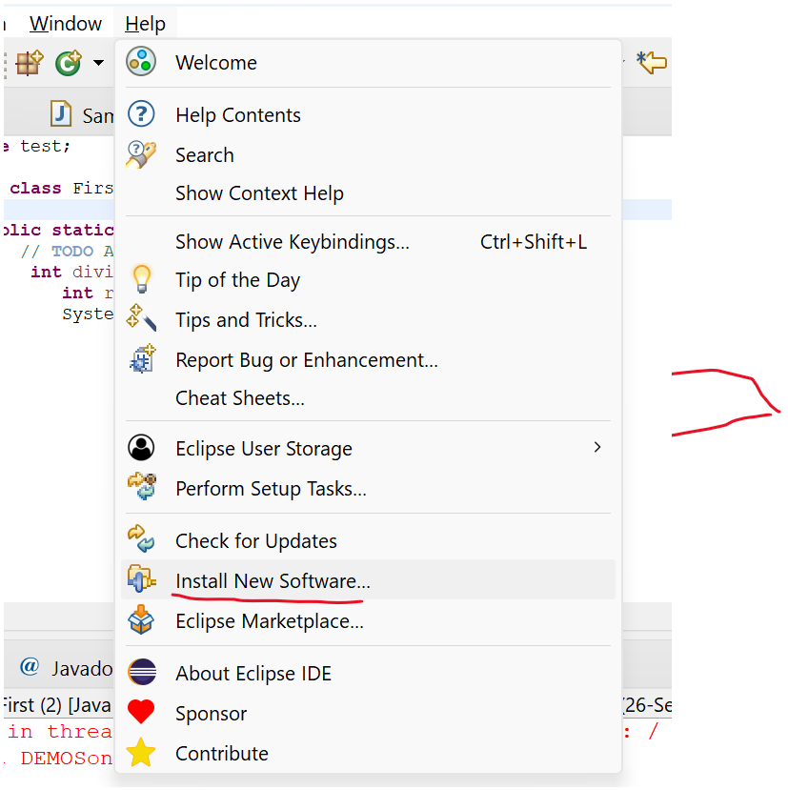

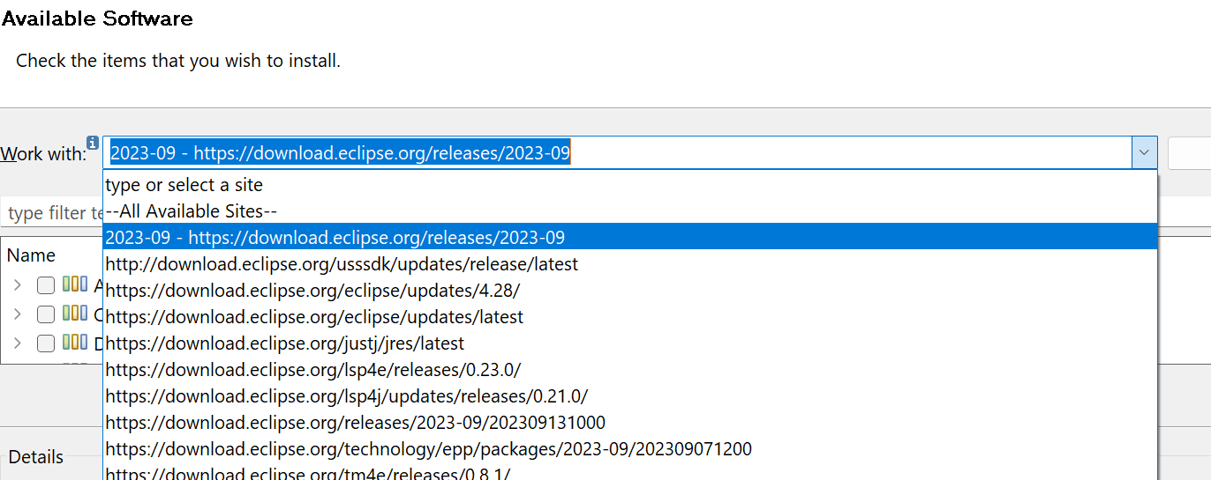

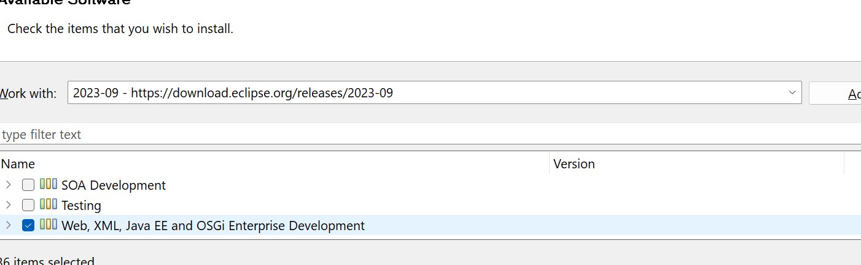

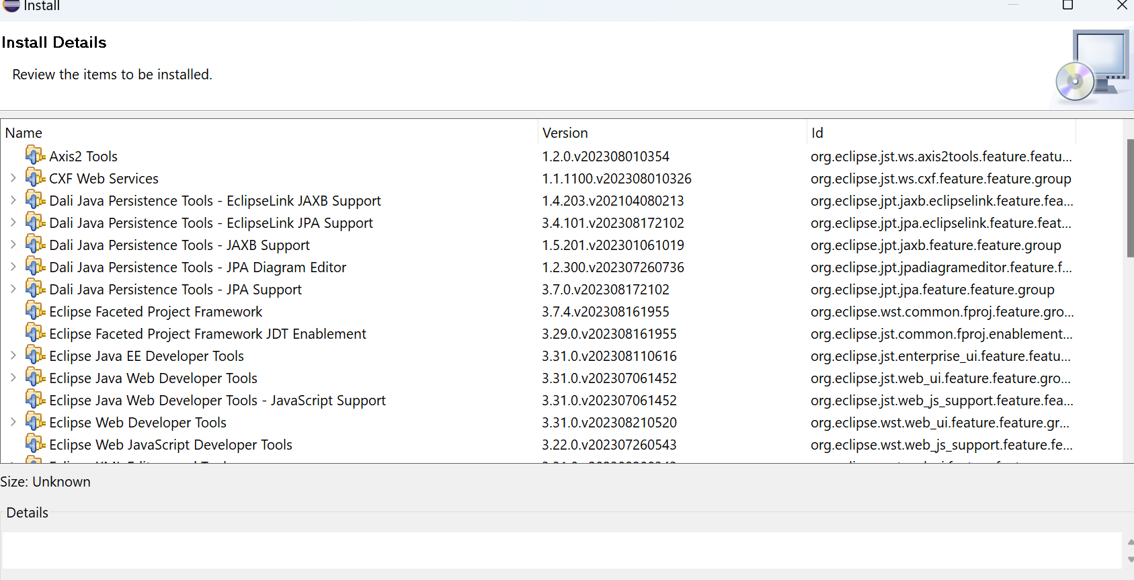

Eclipse bottom you can find the status:

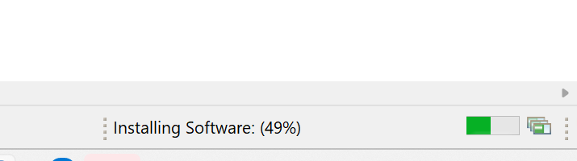

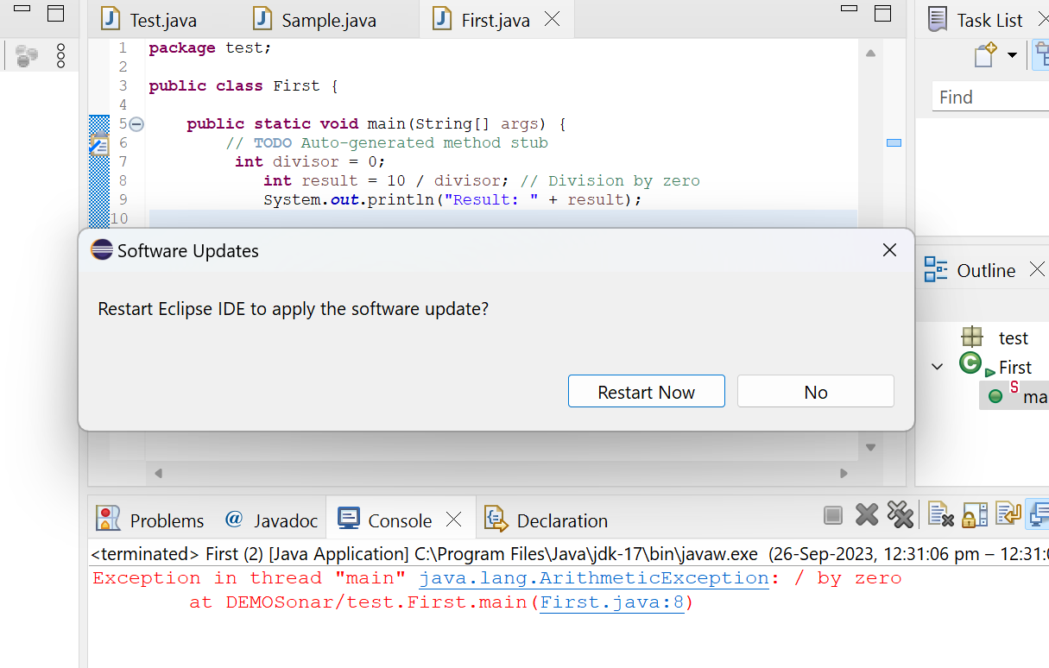

Restart Now.

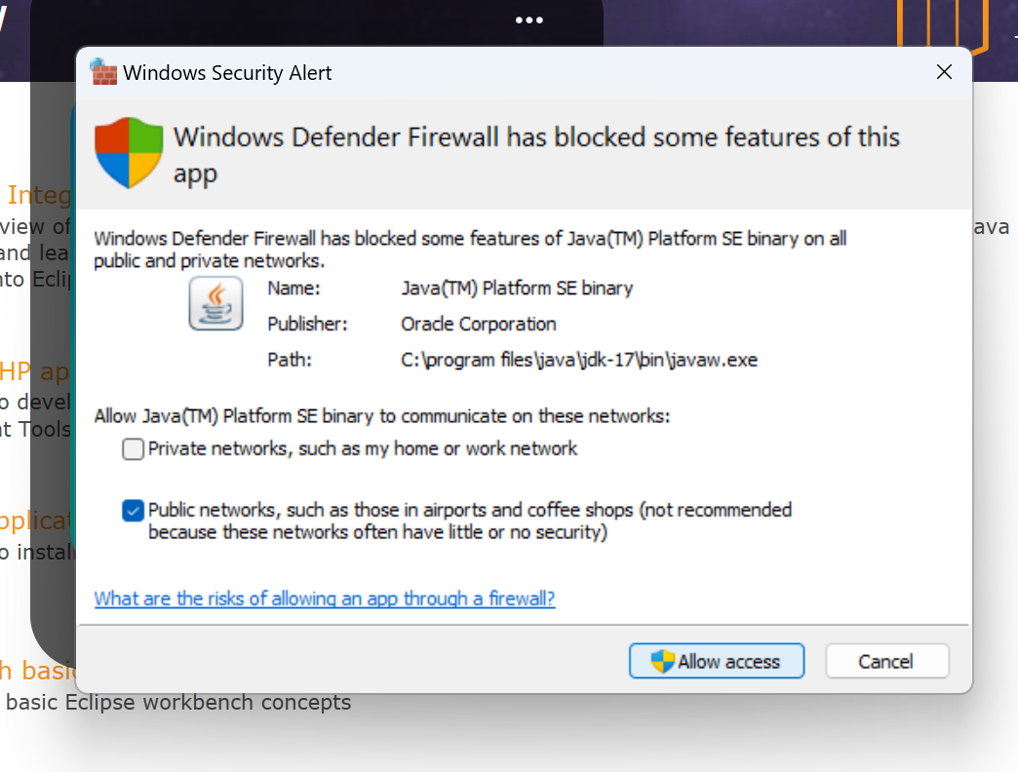

Click Allow access(very Important)

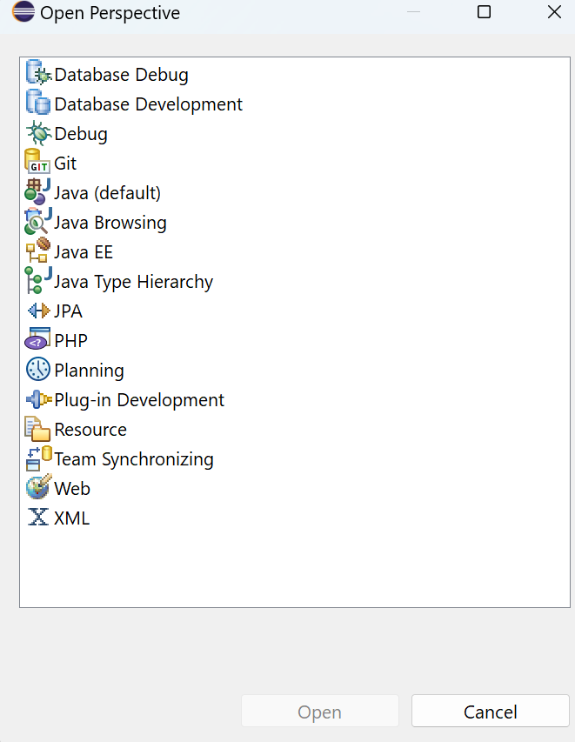

Click on Java EE application then you can find the server option.

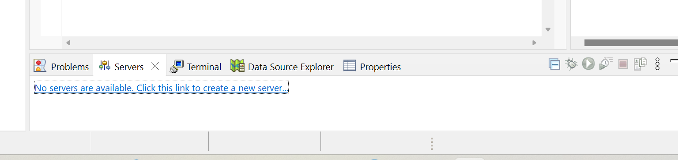

Click on the above link to create a new server.

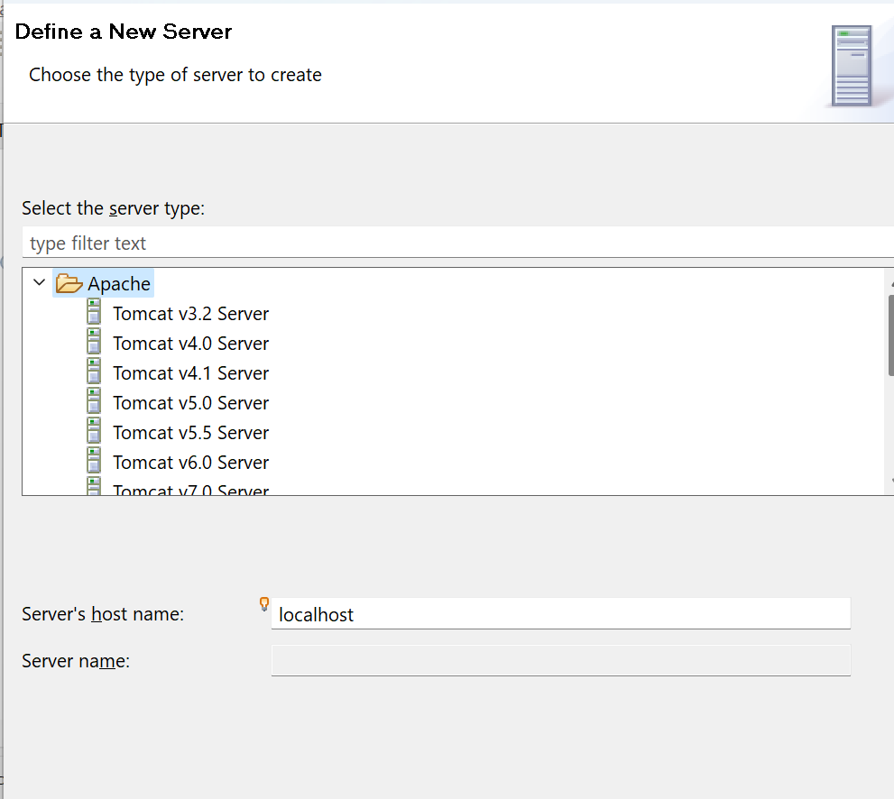

click on apache below mentioned Tomcat v10.1 server.

you can click on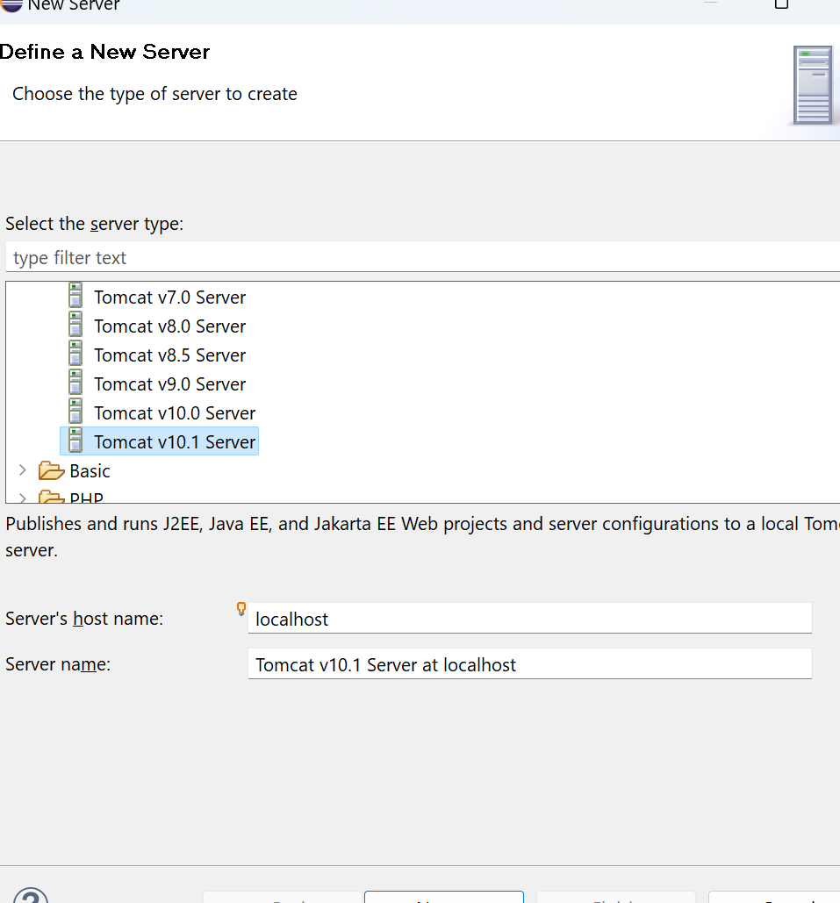

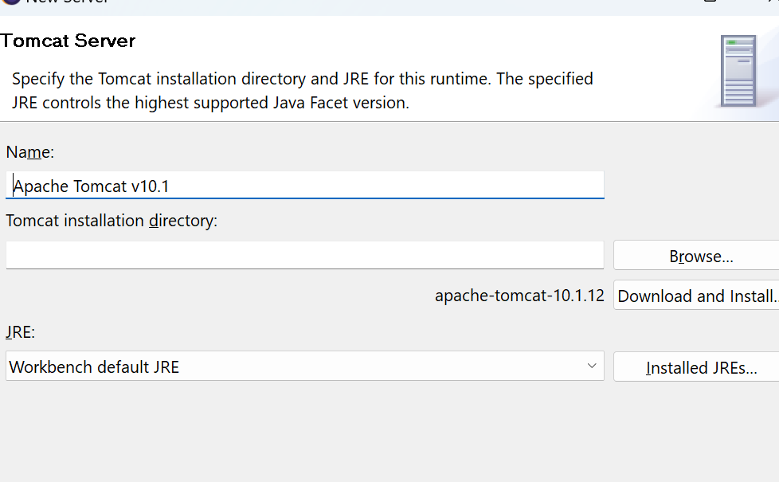

Click on browser where you tomcat file is installed.

C:\Program Files\Apache Software Foundation

Click on Apache 10.1 file then it will ask the permission

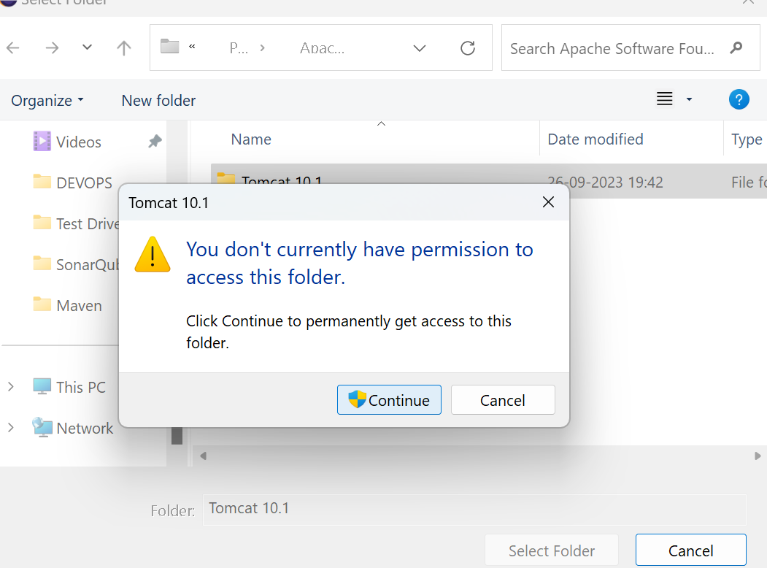

Path C:\Program Files\Apache Software Foundation

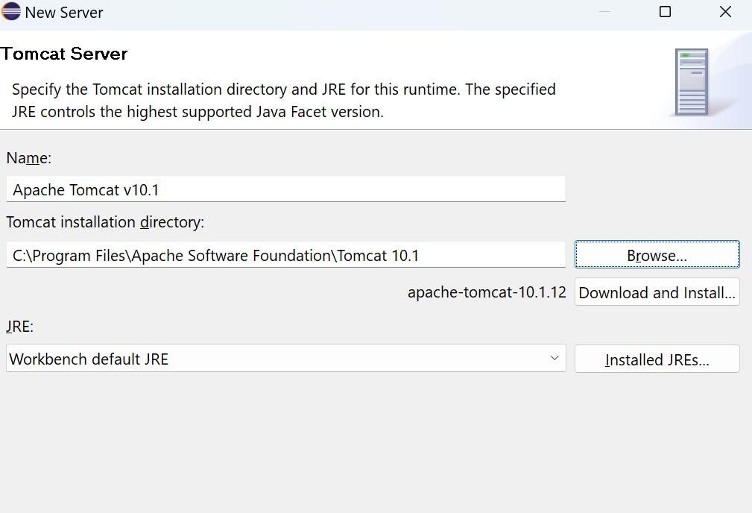

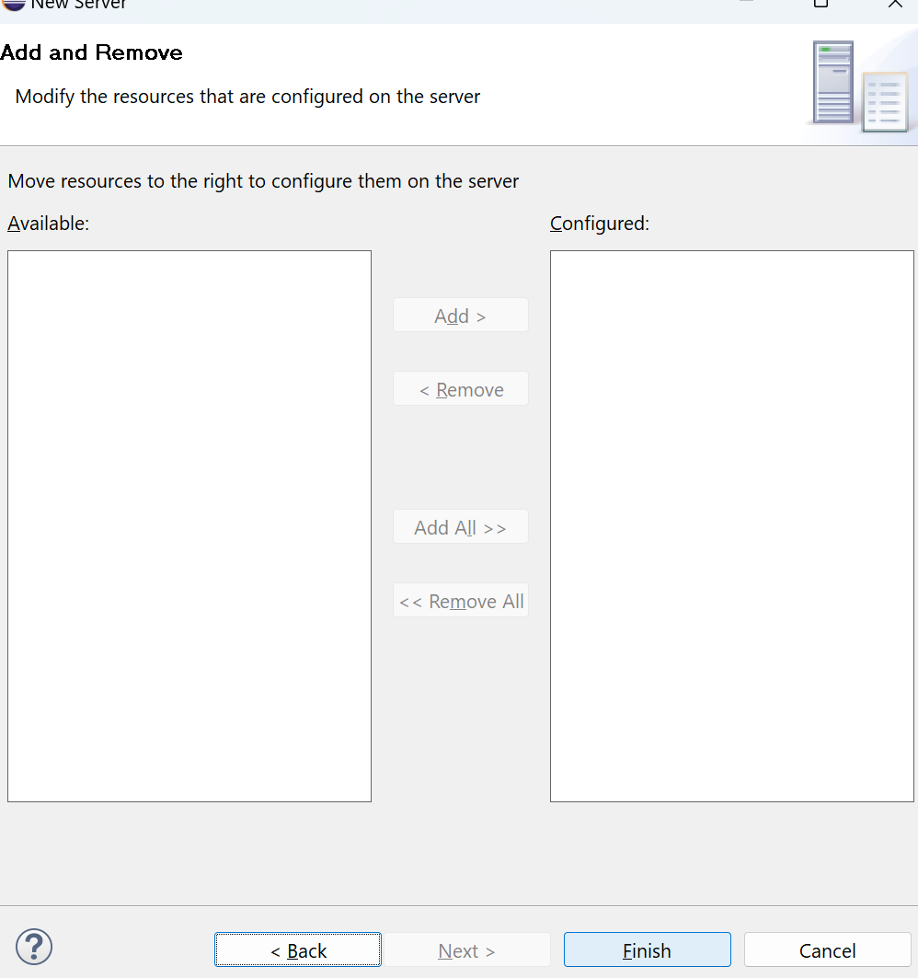

Just click on Finish button.

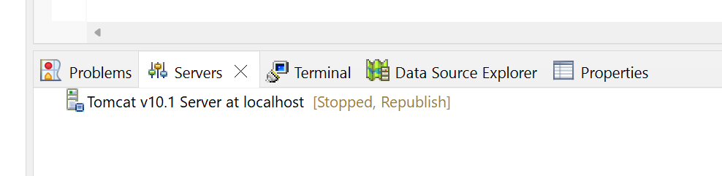

Observe the server is stopped.

Right click and click on the start button

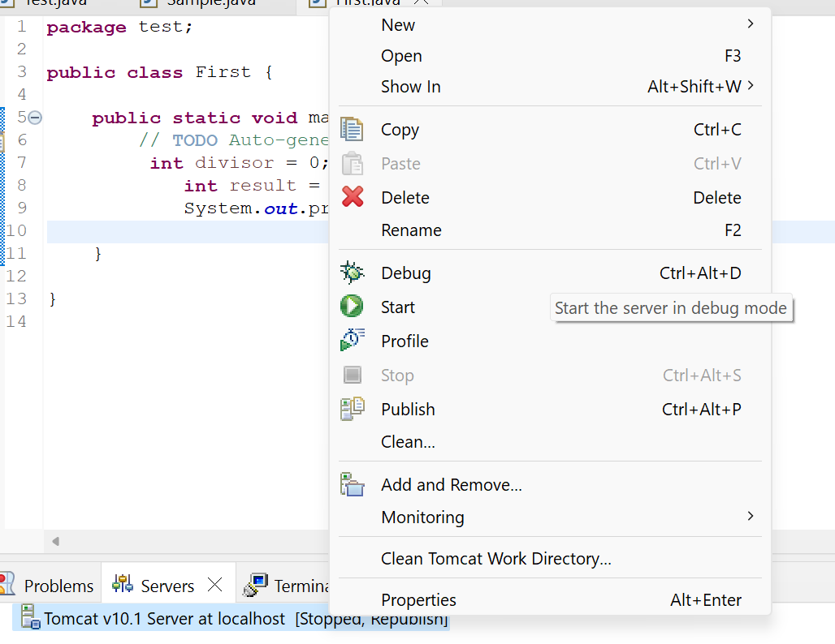

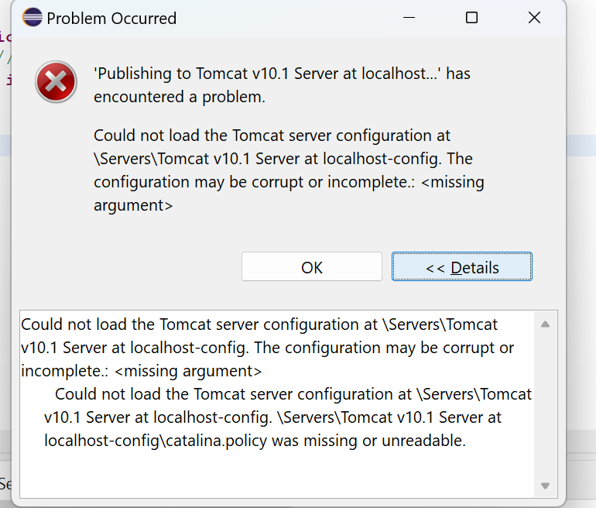

[TOMCAT ERROR RESOLVED:could not load the tomcat server configuration at \servers\tomcat v10.1 server - YouTube](https://www.youtube.com/watch?v=0tm9L1tzX_A)

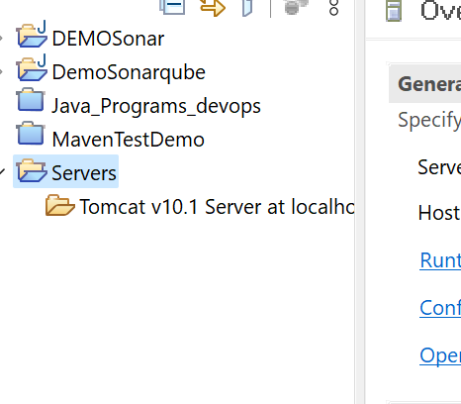

Uder servers not show any files.

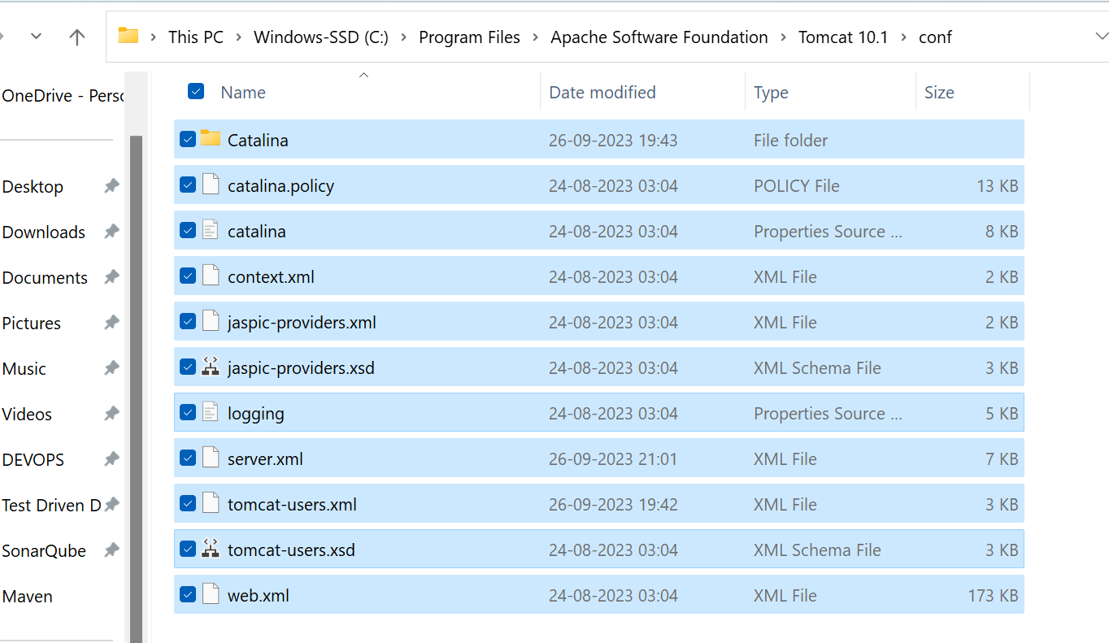

Copy all files and

Go to the workspace ours.

C:\Users\LENOVO\eclipse-workspace_new\Servers\Tomcat v10.1 Server at localhost-config

Paste the files here.

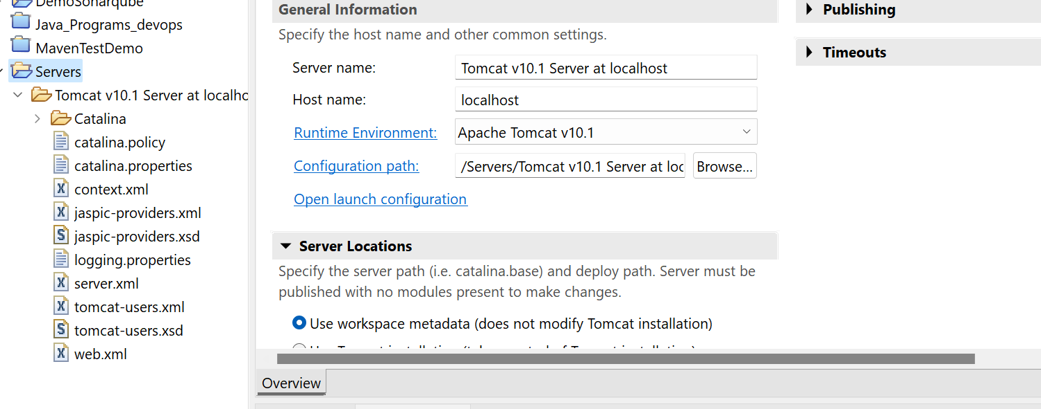

Refresh the project. Now you can find all the required files.

[Tomcat ERROR Solved | The server cannot be started because one or more of the ports are invalid - YouTube](https://www.youtube.com/watch?v=x0-CDNySnfY&t=68s)

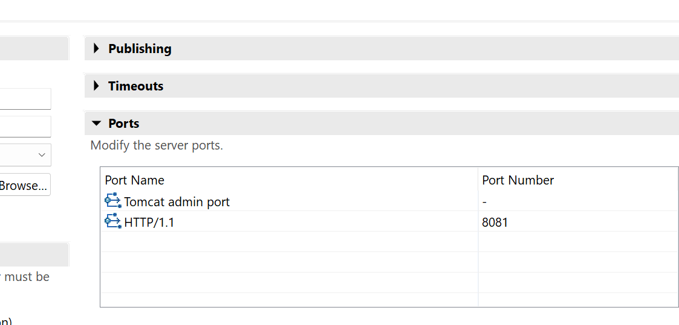

Change port number which you are not used earlier.

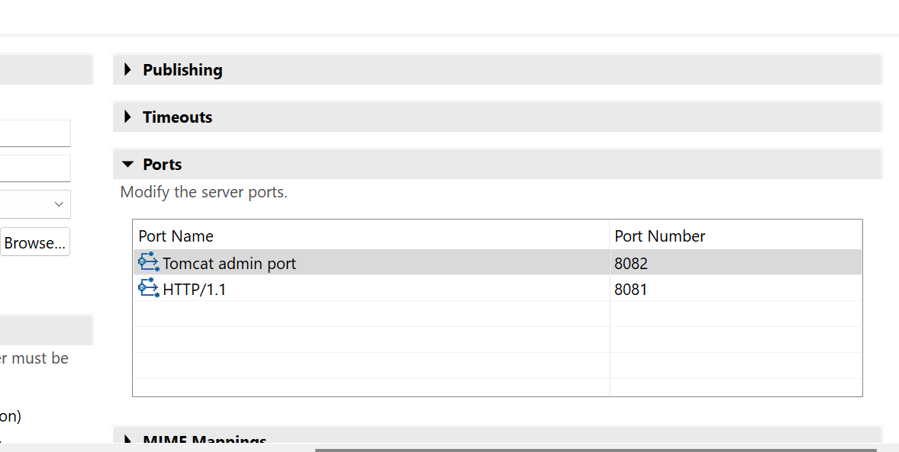

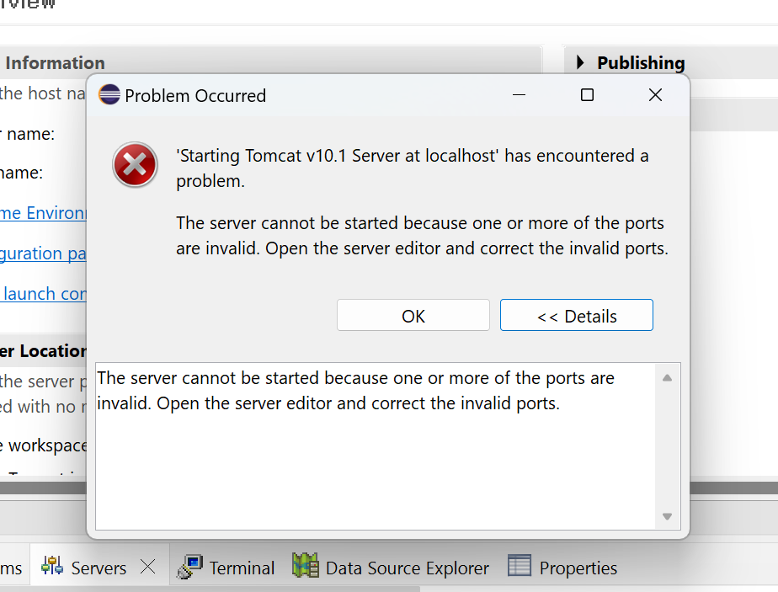

Create a new Web project and run on the Tomcat server.

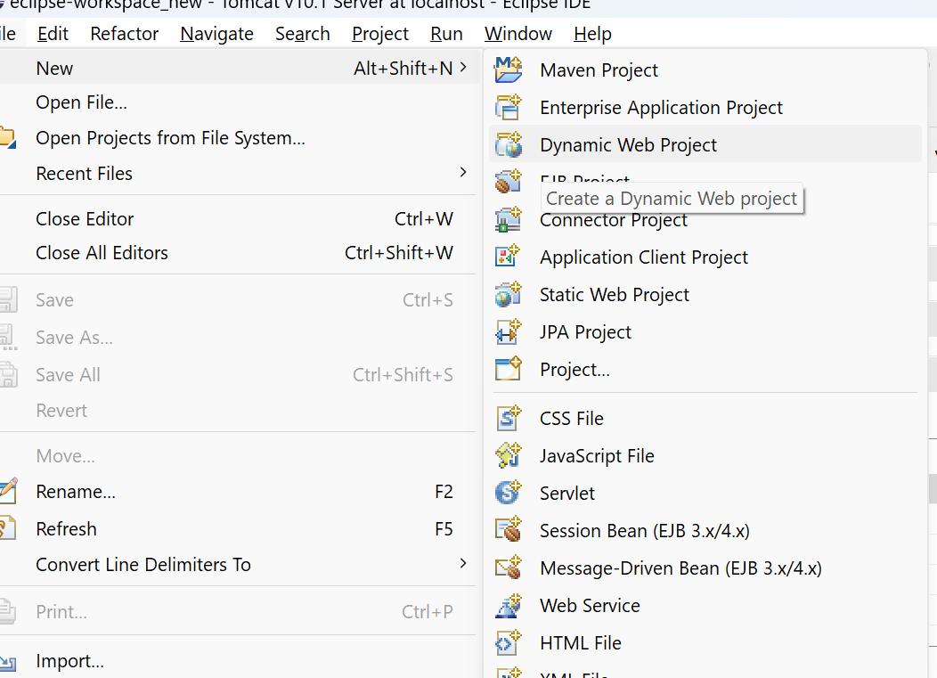

Click on create a Dynamic Web Project

Give DemoServlet

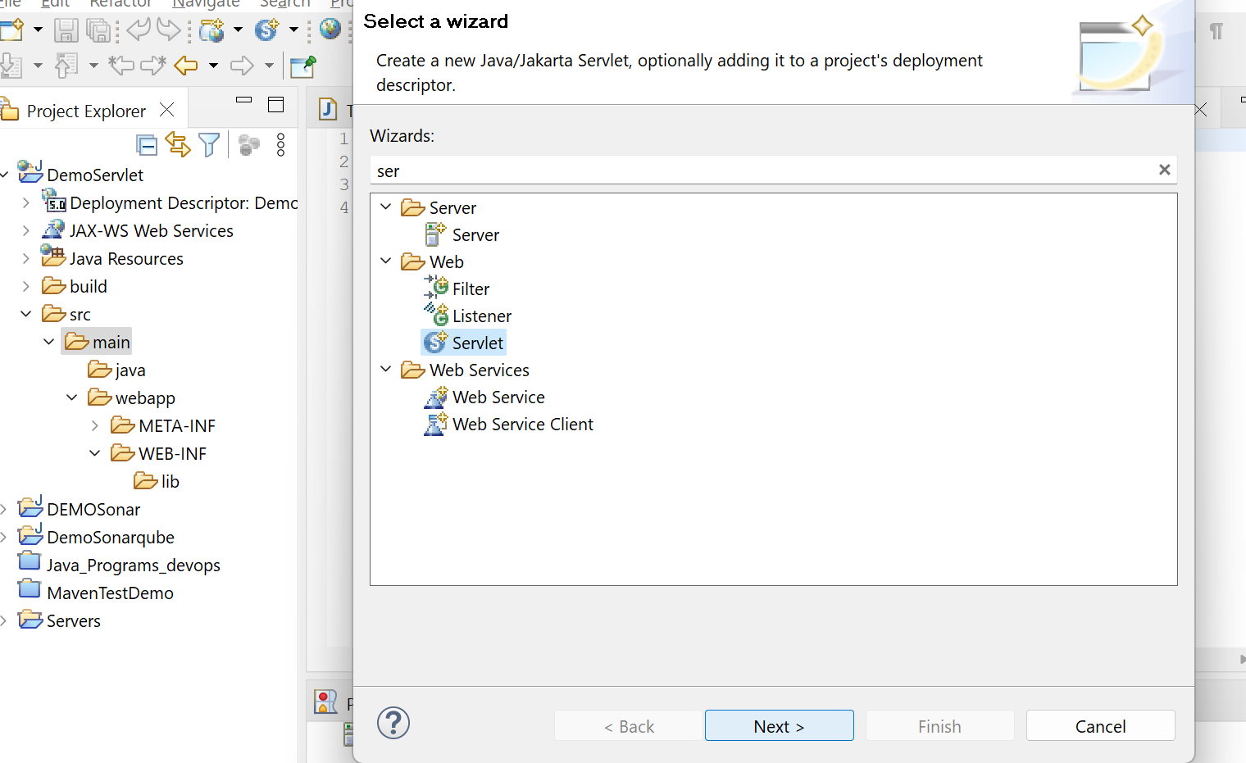right click on main folder and new you can find the Servlet.

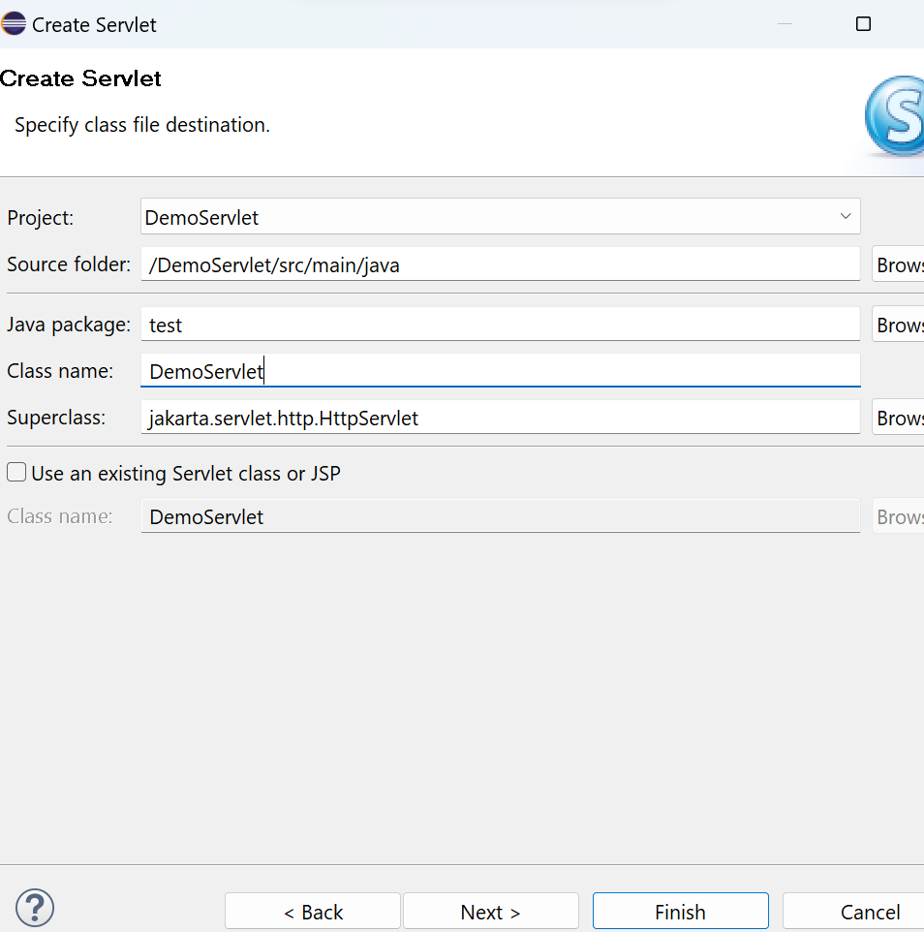

Give the package name and classname.

Click finish.

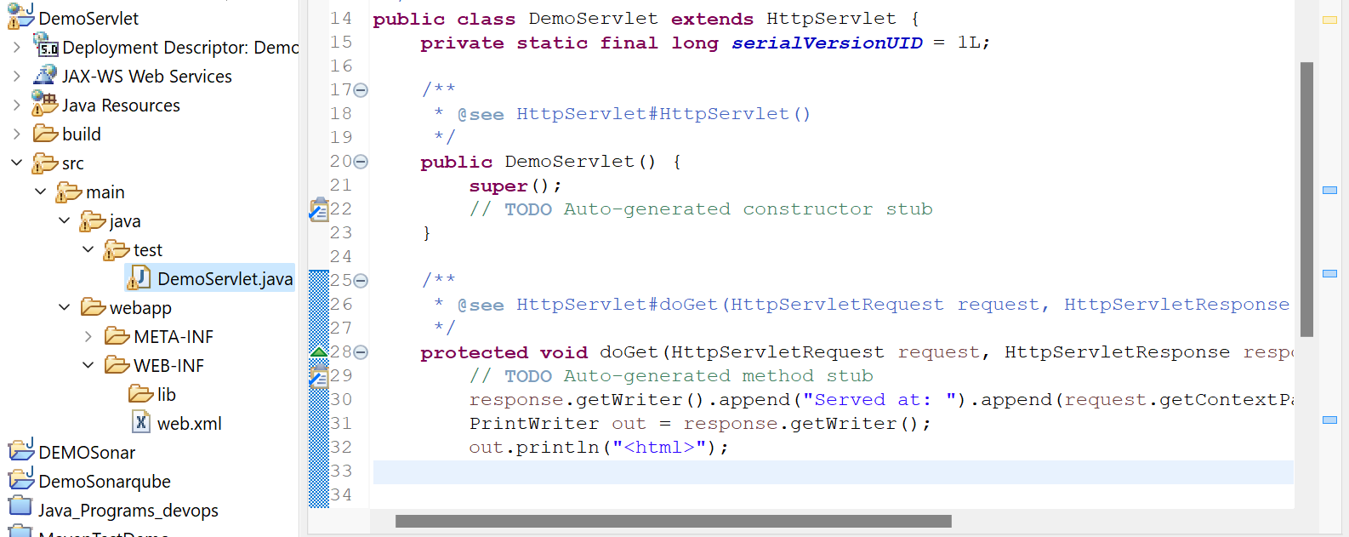

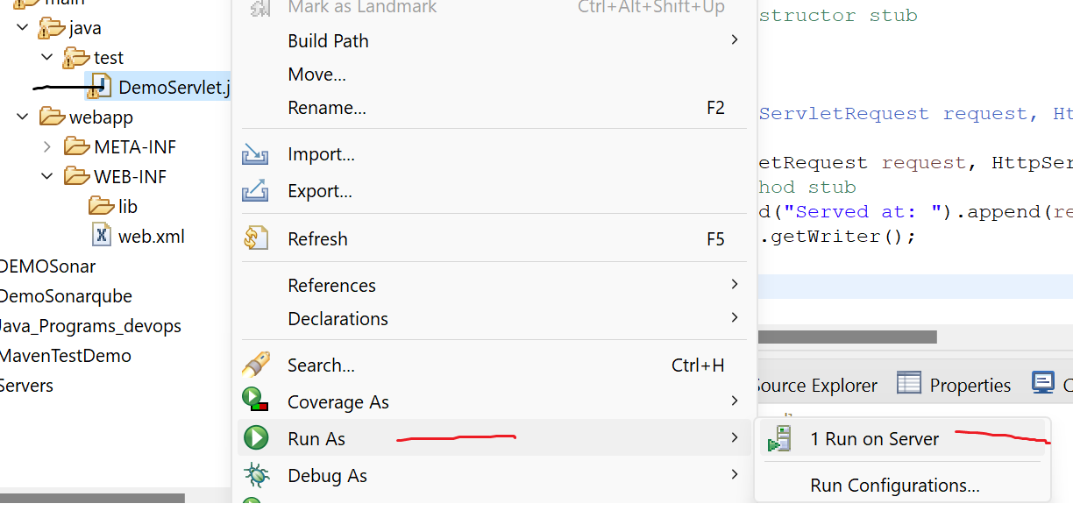

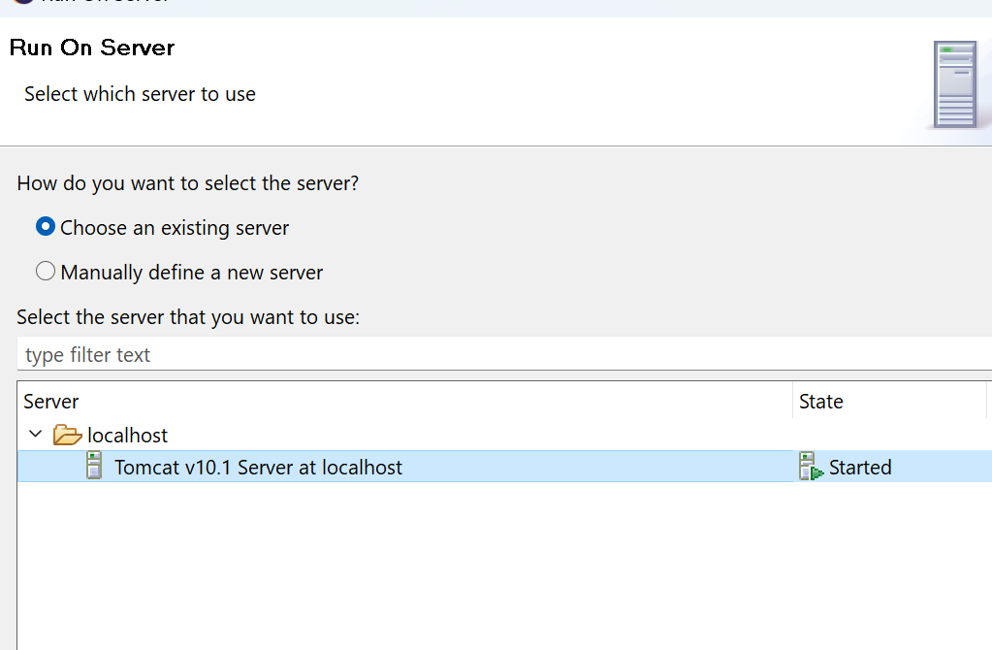

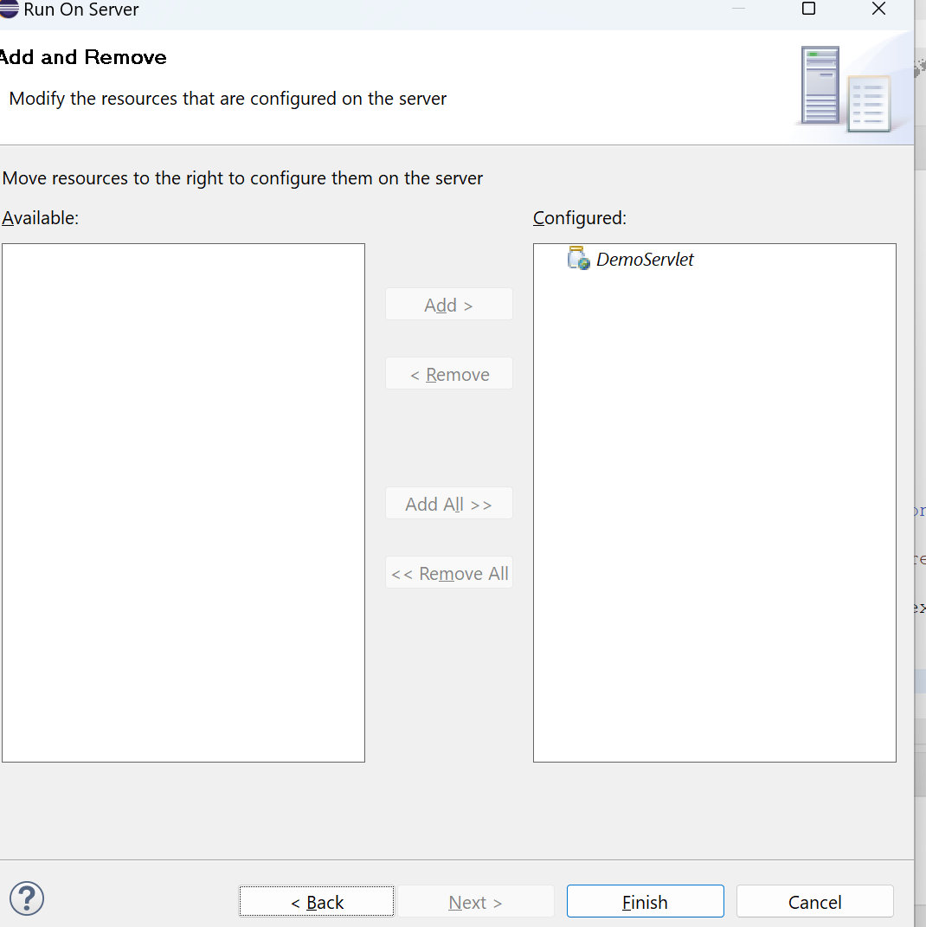 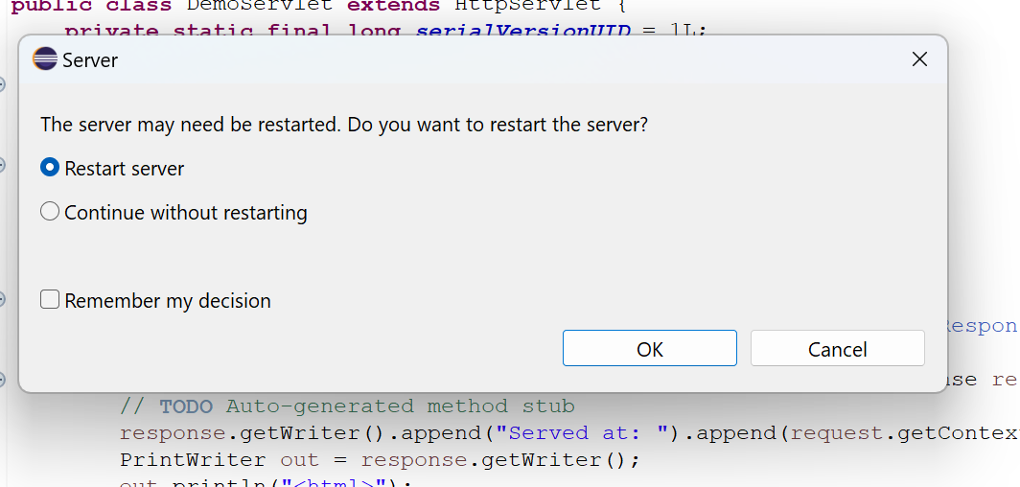

**protected** **void** doGet(HttpServletRequest request, HttpServletResponse response) **throws** ServletException, IOException {

// **TODO** Auto-generated method stub

PrintWriter out = response.getWriter();

response.setContentType("text/html");

//out.println("<h1>html</h1>");

out.println("<html>");

out.println("<head>");

out.println("<title>Hello, World Servlet</title>");

out.println("</head>");

out.println("<body>");

out.println("<h1>Hello, World!</h1>");

out.println("<p>This is a simple servlet example.</p>");

out.println("</body>");

out.println("</html>");

}

modify the code and re run the application

